

OPTICAL FIBER CABLE DATA SHEET

CABLE CODE/CABLE TYPE
A-DQ(BN)2Y MLT mxn

MULTI LOOSE TUBE, NON METALIC ARMOURED , HDPE JACKET FIBER OPTIC CABLE

KEY FEATURES
Non Metallic Armoured, Jelly Filled Loose Tube, UV- Resistant, Rodent Resistant, Waterproof, PE JACKET

CABLE DRAWING and CROSS SECTION

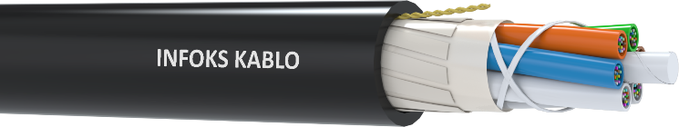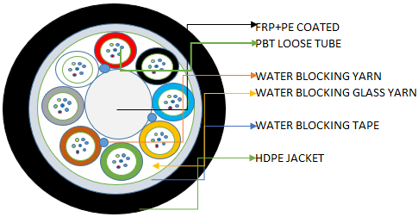

STANDARTS
IEC 60794-1&2,

CONSTRACTIONS
Fiber Type G.652-D,G.657 A1,G.657 A2,OM1,OM2,OM3,OM4,OM5
Fiber Count 12-144
Jacket Color According to customer request
Jacket UV Resistance Carbon Black
CPR Class Fca

APPLICATIONS

Inter Building Voice or Data Communication Networks
FTTC Cabling
Outside Plant
Installed in Ducts & Conduits
Primary & Secondary Distribution
WAN
FTTB Cabling,
Campus Cabling
Directly Buried Underground
Telecommunication Data Trunk Systems
Harsh Premises Environments requiring heavy duty protection
Interconnection of Distribution Boxes, Distribution Frames and the Panels at Customer Side

DIMENSIONS/PHYSICAL SPECIFICATIONS

IEC 60794-1-2
Test method
Number of fibers | 12 | 24 | 36 | 48 | 60 | 72 | 96 | 144
Number of tubes | 1 | 2 | 3 | 4 | 5 | 6 | 8 | 12
Number of dummy Tubes | 5 | 4 | 3 | 2 | 1 | 0 | 0 | 0
OD Tube Max. (mm) | 2,3
OD Tube Nom. (mm) | 2,1
OD Tube Min. (mm) | 1,9
OD cable Max. (mm) | 11,0 |  |  |  |  |  | 13,5 | 16,5
OD cable Nom. (mm) | 10,5 |  |  |  |  |  | 13,0 | 16,0
OD cable Min. (mm) | 10,0 |  |  |  |  |  | 12,5 | 15,5
Max. Jacket Thickness (mm) | 1,8
Min. Jacket Thickness (mm) | 1,5
Minimum Bending radius | 20 x D |  |  |  |  |  |  |  | E11
Max. Operating Load (N) | 1600
Maximum Installation Pulling Load (N) | 2700
Crush (N/100mm) | 2000 |  |  |  |  |  |  |  | E3
Twist (torsion) | 5 turn of 180° on 1m sample, both ways. |  |  |  |  |  |  |  | E7
Impact resistance |  |  |  |  |  |  |  |  | E4
Up to 15mm OD | 4.4J ; 3 x 2 times |  |  |  |  |  |  |  | E4
15 to 17.5mm OD | 7J ; 3 x 2 times |  |  |  |  |  |  |  | E4
17 to 20mm OD | 10J ; 3 x 2 times |  |  |  |  |  |  |  | E4
Over 20mm OD | 13J ; 3 x 2 times |  |  |  |  |  |  |  | E4
Storage temperature Range | -40°C to +70°C |  |  |  |  |  |  |  | F1
Operating temperature Range | -40°C to +70°C |  |  |  |  |  |  |  | F1
Core fluid Penetration | 3m sample, 1m head for 24 hours |  |  |  |  |  |  |  | F5
Nom. Weight (Kg/Km) | 90 |  |  |  |  |  | 120 | 180

QUALIFICATION SPECIFICATIONS
Cable Qualification Standards ANSI/ICEA S-104-696 | EN 187105 | Telcordia GR-20 | Telcordia GR-409

CERTIFICATIONS

RoHS Compliant
ISO 9001:2008 Designed, manufactured and/or distributed under this quality management system

ISO 14001:2004 Designed, Environmental management systems
ISO 18001:2007 Occupational Health and Safety Assessment Series

PACKING and DELIVERY LENGTHS
WOODEN DRUMS, standart delivery lengths are 4000mt

SHEATH MARKING
INFOKS KABLO WEEK/YEAR A-DQ(BN)2Y xxxF TYPE of FIBRE DRUM NO LENGTH (M)

